Default Gateway

🚪 What is a Default Gateway?
# Source: Chatgpt (GPT‑5 Mini) at [12/18/2025]
A Default Gateway is the network device (usually a router) that acts as the access point or exit for computers in a local network to communicate with devices outside their own subnet — such as the internet or other networks.
✅ Think of the default gateway as the "door to the outside world" for your device.

🔧 What It Does
# Source: Chatgpt (GPT‑5 Mini) at [12/18/2025]
When your computer or phone wants to communicate with:
- A website (e.g. www.google.com)
- A remote server
- A device in a different IP range
…it sends the request to the default gateway, which then routes the traffic to the destination.

📦 Example
# Source: Chatgpt (GPT‑5 Mini) at [12/18/2025]
Your PC: 192.168.1.10
Default Gateway: 192.168.1.1
Destination: 142.250.190.4 (Google)
🔁 Here's what happens:
- Your PC checks: Is 142.250.190.4 in my local subnet?
- No → Send the packet to 192.168.1.1 (default gateway)
- The gateway forwards it to the internet

📍 Where You Find It
# Source: Chatgpt (GPT‑5 Mini) at [12/18/2025]
On Windows (CMD):
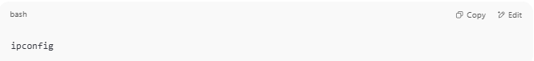
ipconfig

You'll see something like:
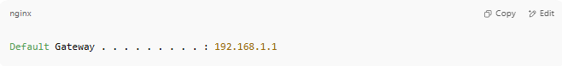
Default Gateway . . . . . . . . . : 192.168.1.1

On Linux/macOS:
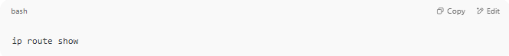
ip route show

📡 Common Devices That Act as Default Gateways
# Source: Chatgpt (GPT‑5 Mini) at [12/18/2025]
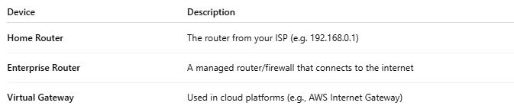
Device | Description
Home Router | The router from your ISP (e.g. 192.168.0.1)
Enterprise Router | A managed router/firewall that connects to the internet
Virtual Gateway | Used in cloud platforms (e.g., AWS Internet Gateway)

🧠 Key Points
# Source: Chatgpt (GPT‑5 Mini) at [12/18/2025]
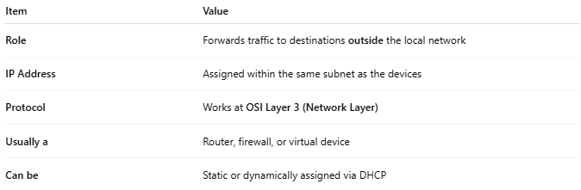
Item | Value
Role | Forwards traffic to destinations outside the local network
IP Address | Assigned within the same subnet as the devices
Protocol | Works at OSI Layer 3 (Network Layer)
Usually a | Router, firewall, or virtual device
Can be | Static or dynamically assigned via DHCP

✅ Pros
# Source: Chatgpt (GPT‑5 Mini) at [12/18/2025]
- ✅ Enables internet access
- ✅ Centralized exit point for security and monitoring
- ✅ Automatically assigned via DHCP in most networks

❌ Misconfigurations Can Cause
# Source: Chatgpt (GPT‑5 Mini) at [12/18/2025]
- ❌ No internet access
- ❌ Failed connections to remote networks
- ❌ Routing loops or drops

📌 Summary
# Source: Chatgpt (GPT‑5 Mini) at [12/18/2025]
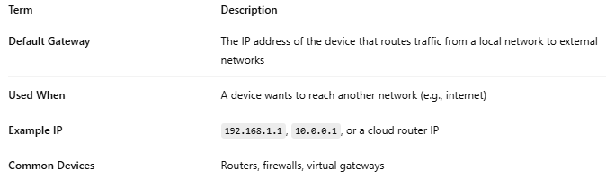
Term | Description
Default Gateway | The IP address of the device that routes traffic from a local network to external networks
Used When | A device wants to reach another network (e.g., internet)
Example IP | 192.168.1.1, 10.0.0.1, or a cloud router IP
Common Devices | Routers, firewalls, virtual gateways

